# Indicator 2.3.3: Level of Urban Greenness

**Greta K. Martin, Jennifer D. Stowell, Patrick L. Kinney & Susan C. Anenberg**

**Methods**

The urban center spatial extents were defined by the Global Human Settlement (GHS) program of the European commission.(1) The GHS uses a blend of demographic and remote sensing data to define more than 10,000 urban centers worldwide. We computed the greenness indicator for global urban centers with populations larger than 500,000. For countries that lacked urban centers meeting this threshold, we selected the most populated city where possible, giving a final count of 1,041 urban centers across 174 countries. Due to missing data in the GHS data, 22 countries (mostly small island states) were not represented in the analysis.

Data on population size for all years came from the Gridded Population of the World from the Center for International Earth Science Information Network (CIESN, Columbia University), which models the distribution of human population at the 100m x 100m resolution.(2)

Green spaces were estimated using the normalized difference vegetation index (NDVI). The NDVI is the most commonly used satellite-based vegetation index and it calculates the ratio of the differences between near infrared radiation and visible radiation to the sum of these two measures. NDVI values range from -1.0 to 1.0 with values less than 0 indicate bodies of water and values close to 1 indicating high levels of vegetation density or greenness.(3) For this process, we utilized publicly available data from the Landsat satellite, a joint program of the USGS and NASA.(4) Landsat images the Earth’s surface at 30-meter resolution approximately every two weeks (~16 days). To account for seasonal fluctuations, we computed NDVI for each of the following time periods (with season labels based on the northern hemisphere):

* Winter—December 1 of previous year through February 28
* Spring—March 1 through May 31
* Summer—June 1 through August 31
* Fall—September 1 through November 30

We did this for ten different years: 2015-2024. Landsat 8 was used to estimate values for the included years. For each year and city, a total of four exposure metrics were calculated: peak NDVI (maximum NDVI across the four seasons); annual mean NDVI based on the four-season average NDVI; population-weighted peak NDVI; and population-weighted mean NDVI. The population weighted NDVI was computed for each city by multiplying each NDVI value (peak and four-season average) by the population size of the corresponding year within the same 100m x 100m raster, summing up over the weighted values within the urban extent, and dividing by the sum of the weights, as shown by the equation below:

Additional analyses include subsetting the data by levels of the Human Development Index (HDI, see Figure 1), climate regions as defined by the Köppen Climate Classification System (see Figure 2), Lancet Countdown regional country groupings, and WHO region (see Figure 3).(5) Google Earth Engine was used to generate the raw data for analysis. The R Statistical Software was used for data analysis and management and to compute the four metrics described above. We defined ‘Level of Greenness’ according to the table below (Table 1):

Table 1: Categorization of Greenness Levels

|  |  |
| --- | --- |
| Level of Greenness | Population-Weighted Peak NDVI |
| Exceptionally Low | <0.20 |
| Very low | 0.20-0.29 |
| Low | 0.30-0.39 |
| Moderate | 0.40-0.49 |
| High | 0.50-0.59 |
| Very High | 0.60-0.69 |
| Exceptionally High | ≥0.70 |

**Data**

1. Global Human Settlement Programme of the European Commission (GHS) used to identify urban centers.(1)
2. Population size identified from NASA GPWv4.(2)
3. Satellite data were downloaded from the publicly available Landsat satellite, a joint program of the US Geological Survey and NASA.(4)
4. Global climate regions from the Köppen Climate Classification System.(5)
5. Human Development Index. (6)

**Caveats**

This approach has some limitations. First, while satellite-based vegetation measures are used extensively to measure greenness, the NDVI cannot decipher the quality of greenness (e.g., curated park vs vacant lot), the type of green space (e.g., park vs. forest), the type of vegetation (e.g., shrubs vs. trees) or social characteristics (e.g., level of security). However, studies have demonstrated that NDVI performs adequately when compared with environmental psychologists’ evaluations of green spaces.(7) In addition, reviews of the literature on greenness and health have been undertaken and found consistent and strong evidence of associations of higher greenness measured by NDVI, with improvements in birthweights, physical activity, lower mortality rates, and lower levels of depression.(8, 9) Second, it is important to note that missing values due to cloud cover or other factors may limit the generalizability of the findings.

**Future form of indicator**

Future versions of the urban greenness indicator will continue to assess changes in NDVI over time. In the coming years, we intend to incorporate blue space as a separate indicator and combined with greenspace. We also plan to explore the combination of urban green space with other indicators such as extreme temperature and vulnerability.

**Additional analysis**

The findings below represent multiple measures of urban greenness and allow for examination of trends over time.



Table 2: Global percent moderate or above (population-weighted average peak-season NDVI ≥0.40)

|  |  |
| --- | --- |
| **Year** | **% > Moderate Greenness** |
| 2015 | 28% (288/1041) |
| 2020 | 28% (286/1041) |
| 2021 | 27% (280/1041) |
| 2022 | 27% (281/1041) |
| 2023 | 28% (291/1041) |

|  |  |
| --- | --- |
| **Year** | **Pop-weighted average peak-season NDVI** |
| 2015 | 0.34 |
| 2020 | 0.34 |
| 2021 | 0.34 |
| 2022  2023 | 0.34  0.34 |

Table 3: Global average population-weighted peak-season NDVI

Table 4: Population-weighted peak-season NDVI by HDI

|  |  |  |  |  |  |
| --- | --- | --- | --- | --- | --- |
| **HDI-level** | **2015** | **2020** | **2021** | **2022** | **2023** |
| **Low** | 0.31 | 0.30 | 0.29 | 0.29 | 0.30 |
| **Medium** | 0.37 | 0.37 | 0.37 | 0.37 | 0.37 |
| **High** | 0.31 | 0.32 | 0.31 | 0.32 | 0.32 |
| **Very High** | 0.36 | 0.36 | 0.35 | 0.35 | 0.35 |

Table 5: Population-weighted peak-season NDVI by climate region

|  |  |  |  |  |  |
| --- | --- | --- | --- | --- | --- |
| **Climate Region** | **2015** | **2020** | **2021** | **2022** | **2023** |
| **Arid** | 0.24 | 0.25 | 0.24 | 0.24 | 0.24 |
| **Continental** | 0.37 | 0.39 | 0.38 | 0.38 | 0.39 |
| **Polar** | 0.14 | 0.13 | 0.13 | 0.14 | 0.11 |
| **Temperate** | 0.35 | 0.35 | 0.35 | 0.35 | 0.35 |
| **Tropical** | 0.39 | 0.38 | 0.38 | 0.38 | 0.38 |

Table 6: Population-weighted peak-season NDVI by WHO region

|  |  |  |  |  |  |
| --- | --- | --- | --- | --- | --- |
| **WHO Region** | **2015** | **2020** | **2021** | **2022** | **2023** |
| **African** | 0.33 | 0.32 | 0.32 | 0.31 | 0.33 |
| **Americas** | 0.34 | 0.34 | 0.33 | 0.34 | 0.31 |
| **E Mediterranean** | 0.22 | 0.22 | 0.21 | 0.20 | 0.22 |
| **European** | 0.37 | 0.37 | 0.37 | 0.37 | 0.37 |
| **SE Asian** | 0.40 | 0.40 | 0.41 | 0.40 | 0.40 |
| **W Pacific** | 0.31 | 0.32 | 0.31 | 0.32 | 0.32 |

Table 7: Population-weighted peak-season NDVI by WHO region

|  |  |  |  |  |  |
| --- | --- | --- | --- | --- | --- |
| **LCD Region** | **2015** | **2020** | **2021** | **2022** | **2023** |
| **African** | 0.31 | 0.30 | 0.29 | 0.29 | 0.30 |
| **Asia** | 0.34 | 0.34 | 0.34 | 0.34 | 0.34 |
| **European** | 0.40 | 0.40 | 0.40 | 0.39 | 0.40 |
| **North American** | 0.39 | 0.40 | 0.37 | 0.40 | 0.38 |
| **Oceania** | 0.35 | 0.33 | 0.35 | 0.34 | 0.35 |
| **SIDS** | 0.38 | 0.38 | 0.38 | 0.38 | 0.38 |
| **South/Central America** | 0.31 | 0.30 | 0.30 | 0.30 | 0.30 |

Table 8: Percent moderate or above by HDI (population-weighted average peak-season NDVI ≥0.40)

|  |  |  |  |  |  |
| --- | --- | --- | --- | --- | --- |
| **HDI-level** | **2015** | **2020** | **2021** | **2022** | **2023** |
| **Low** | 18% (19/105) | 18% (19/105) | 15% (16/105) | 13% (14/105) | 17% (18/105) |
| **Medium** | 37% (110/297) | 36% (108/297) | 40% (118/297) | 36% (108/297) | 41% (122/297) |
| **High** | 17% (63/373) | 16% (61/373) | 16% (61/373) | 18% (67/373) | 18% (68/373) |
| **Very High** | 37% (95/254) | 38% (96/254) | 33% (84/254) | 36% (91/254) | 33% (83/254) |

Table 9: Climate region percent moderate or above (population-weighted average peak-season NDVI ≥0.40)

|  |  |  |  |  |  |
| --- | --- | --- | --- | --- | --- |
| **Climate Region** | **2015** | **2020** | **2021** | **2022** | **2023** |
| **Arid** | 4% (9/233) | 5% (11/233) | 6% (13/233) | 5% (12/233) | 4% (9/233) |
| **Continental** | 48% (69/144) | 44% (63/144) | 43% (62/144) | 51% (73/144) | 42% (60/144) |
| **Polar** | 0% (0/1) | 0% (0/1) | 0% (0/1) | 0% (0/1) | 0% (0/1) |
| **Temperate** | 28% (102/368) | 27% (98/368) | 26% (93/368) | 24% (87/368) | 29% (107/368) |
| **Tropical** | 39% (115/295) | 42% (123/295) | 40% (117/295) | 40% (117/295) | 38% (111/295) |

Table 10: Percent moderate or above by WHO region (population-weighted average peak-season NDVI ≥0.40)

|  |  |  |  |  |  |
| --- | --- | --- | --- | --- | --- |
| **WHO Region** | **2015** | **2020** | **2021** | **2022** | **2023** |
| **African** | 21% (24/112) | 20% (23/112) | 18% (20/112) | 18% (20/112) | 23% (26/112) |
| **Americas** | 28% (49/178) | 28% (49/178) | 25% (45/178) | 25% (45/178) | 25% (44/178) |
| **E Mediterranean** | 5% (6/113) | 6% (7/113) | 5% (6/113) | 4% (4/113) | 4% (5/113) |
| **European** | 44% (70/160) | 45% (72/160) | 40% (64/160) | 44% (71/160) | 43% (68/160) |
| **SE Asian** | 47% (120/257) | 46% (117/257) | 49% (126/257) | 45% (116/257) | 47% (120/257) |
| **W Pacific** | 9% (19/221) | 8% (17/221) | 8% (18/221) | 11% (24/221) | 11% (25/221) |

Table 11: Percent moderate or above by Lancet Countdown region (population-weighted average peak-season NDVI ≥0.40)

|  |  |  |  |  |  |
| --- | --- | --- | --- | --- | --- |
| **LCD Region** | **2015** | **2020** | **2021** | **2022** | **2023** |
| **African** | 17% (26/150) | 16% (24/150) | 15% (22/150) | 14% (21/150) | 18% (27/150) |
| **Asia** | 24% (137/569) | 24% (135/569) | 25% (141/569) | 24% (135/569) | 25% (145/569) |
| **European** | 55% (70/128) | 56% (72/128) | 50% (64/128) | 55% (71/128) | 53% (68/128) |
| **North American** | 60% (34/57) | 58% (33/57) | 49% (28/57) | 51% (29/57) | 46% (26/57) |
| **Oceania** | 17% (1/6) | 0% (0/6) | 0% (0/6) | 17% (1/6) | 0% (0/6) |
| **SIDS** | 27% (6/22) | 41% (9/22) | 45% (10/22) | 50% (11/22) | 55% (12/22) |
| **South/Central America** | 12% (13/109) | 11% (12/109) | 13% (14/109) | 11% (12/109) | 12% (13/109) |

Table 12: Estimates of Urban Green Space by HDI (2015)

|  |  |  |  |  |
| --- | --- | --- | --- | --- |
| **HDI-level** | **Peak NDVI** | **Four-season NDVI** | **Pop. weighted Peak NDVI** | **Pop. weighted Four-season NDVI** |
| **Low** | 0.32 | 0.26 | 0.31 | 0.25 |
| **Medium** | 0.38 | 0.31 | 0.37 | 0.31 |
| **High** | 0.34 | 0.27 | 0.31 | 0.25 |
| **Very High** | 0.37 | 0.29 | 0.36 | 0.28 |
| **Global Mean** | 0.35 | 0.29 | 0.34 | 0.27 |

Table 13: Estimates of Urban Green Space by HDI (2020)

|  |  |  |  |  |
| --- | --- | --- | --- | --- |
| **HDI-level** | **Peak NDVI** | **Four-season NDVI** | **Pop. weighted Peak NDVI** | **Pop. weighted Four-season NDVI** |
| **Low** | 0.31 | 0.26 | 0.30 | 0.25 |
| **Medium** | 0.38 | 0.32 | 0.37 | 0.31 |
| **High** | 0.35 | 0.28 | 0.32 | 0.25 |
| **Very High** | 0.36 | 0.29 | 0.36 | 0.28 |
| **Global Mean** | 0.35 | 0.29 | 0.34 | 0.27 |

Table 14: Estimates of Urban Green Space by HDI (2021)

|  |  |  |  |  |
| --- | --- | --- | --- | --- |
| **HDI-level** | **Peak NDVI** | **Four-season NDVI** | **Pop. weighted Peak NDVI** | **Pop. weighted Four-season NDVI** |
| **Low** | 0.31 | 0.25 | 0.30 | 0.24 |
| **Medium** | 0.38 | 0.31 | 0.37 | 0.30 |
| **High** | 0.34 | 0.27 | 0.31 | 0.25 |
| **Very High** | 0.36 | 0.28 | 0.35 | 0.27 |
| **Global Mean** | 0.36 | 0.28 | 0.35 | 0.27 |

Table 15: Estimates of Urban Green Space by HDI (2022)

|  |  |  |  |  |
| --- | --- | --- | --- | --- |
| **HDI-level** | **Peak NDVI** | **Four-season NDVI** | **Pop. weighted Peak NDVI** | **Pop. weighted Four-season NDVI** |
| **Low** | 0.30 | 0.25 | 0.29 | 0.24 |
| **Medium** | 0.37 | 0.31 | 0.37 | 0.30 |
| **High** | 0.34 | 0.28 | 0.32 | 0.26 |
| **Very High** | 0.36 | 0.28 | 0.35 | 0.27 |
| **Global Mean** | 0.35 | 0.28 | 0.34 | 0.27 |

Table 16: Estimates of Urban Green Space by HDI (2023)

|  |  |  |  |  |
| --- | --- | --- | --- | --- |
| **HDI-level** | **Peak NDVI** | **Four-season NDVI** | **Pop. weighted Peak NDVI** | **Pop. weighted Four-season NDVI** |
| **Low** | 0.31 | 0.26 | 0.30 | 0.25 |
| **Medium** | 0.38 | 0.31 | 0.37 | 0.31 |
| **High** | 0.34 | 0.28 | 0.32 | 0.26 |
| **Very High** | 0.36 | 0.28 | 0.35 | 0.28 |
| **Global Mean** | 0.35 | 0.29 | 0.34 | 0.28 |

Table 17: Estimates of Urban Green Space by Climate Region (2015)

|  |  |  |  |  |
| --- | --- | --- | --- | --- |
| **Climate Region** | **Peak NDVI** | **Four-season NDVI** | **Pop. weighted Peak NDVI** | **Pop. weighted Four-season NDVI** |
| **Arid** | 0.25 | 0.21 | 0.24 | 0.20 |
| **Continental** | 0.38 | 0.26 | 0.37 | 0.25 |
| **Polar** | 0.17 | 0.14 | 0.14 | 0.12 |
| **Temperate** | 0.37 | 0.30 | 0.35 | 0.28 |
| **Tropical** | 0.41 | 0.35 | 0.39 | 0.33 |

Table 18: Estimates of Urban Green Space by Climate Region (2020)

|  |  |  |  |  |
| --- | --- | --- | --- | --- |
| **Climate Region** | **Peak NDVI** | **Four-season NDVI** | **Pop. weighted Peak NDVI** | **Pop. weighted Four-season NDVI** |
| **Arid** | 0.26 | 0.21 | 0.25 | 0.20 |
| **Continental** | 0.40 | 0.27 | 0.39 | 0.26 |
| **Polar** | 0.15 | 0.13 | 0.13 | 0.11 |
| **Temperate** | 0.36 | 0.30 | 0.35 | 0.29 |
| **Tropical** | 0.40 | 0.35 | 0.39 | 0.33 |

Table 19: Estimates of Urban Green Space by Climate Region (2021)

|  |  |  |  |  |
| --- | --- | --- | --- | --- |
| **Climate Region** | **Peak NDVI** | **Four-season NDVI** | **Pop. weighted Peak NDVI** | **Pop. weighted Four-season NDVI** |
| **Arid** | 0.25 | 0.21 | 0.24 | 0.20 |
| **Continental** | 0.39 | 0.26 | 0.38 | 0.25 |
| **Polar** | 0.16 | 0.12 | 0.13 | 0.10 |
| **Temperate** | 0.36 | 0.29 | 0.35 | 0.28 |
| **Tropical** | 0.40 | 0.34 | 0.38 | 0.33 |

Table 20: Estimates of Urban Green Space by Climate Region (2022)

|  |  |  |  |  |
| --- | --- | --- | --- | --- |
| **Climate Region** | **Peak NDVI** | **Four-season NDVI** | **Pop. weighted Peak NDVI** | **Pop. weighted Four-season NDVI** |
| **Arid** | 0.25 | 0.21 | 0.24 | 0.20 |
| **Continental** | 0.39 | 0.27 | 0.38 | 0.26 |
| **Polar** | 0.17 | 0.13 | 0.14 | 0.11 |
| **Temperate** | 0.36 | 0.30 | 0.35 | 0.28 |
| **Tropical** | 0.40 | 0.34 | 0.38 | 0.33 |

Table 21: Estimates of Urban Green Space by Climate Region (2023)

|  |  |  |  |  |
| --- | --- | --- | --- | --- |
| **Climate Region** | **Peak NDVI** | **Four-season NDVI** | **Pop. weighted Peak NDVI** | **Pop. weighted Four-season NDVI** |
| **Arid** | 0.25 | 0.21 | 0.24 | 0.20 |
| **Continental** | 0.39 | 0.27 | 0.39 | 0.27 |
| **Polar** | 0.14 | 0.11 | 0.11 | 0.09 |
| **Temperate** | 0.37 | 0.30 | 0.35 | 0.29 |
| **Tropical** | 0.40 | 0.34 | 0.38 | 0.28 |

Table 22: Estimates of Urban Green Space by WHO region (2015)

|  |  |  |  |  |
| --- | --- | --- | --- | --- |
| **WHO Region** | **Peak NDVI** | **Four-season NDVI** | **Pop. weighted Peak NDVI** | **Pop. weighted Four-season NDVI** |
| **African** | 0.35 | 0.28 | 0.33 | 0.26 |
| **Americas** | 0.36 | 0.31 | 0.34 | 0.29 |
| **E Mediterranean** | 0.23 | 0.20 | 0.22 | 0.19 |
| **European** | 0.38 | 0.29 | 0.37 | 0.28 |
| **SE Asian** | 0.41 | 0.34 | 0.41 | 0.34 |
| **W Pacific** | 0.33 | 0.25 | 0.30 | 0.23 |

Table 23: Estimates of Urban Green Space by WHO region (2020)

|  |  |  |  |  |
| --- | --- | --- | --- | --- |
| **WHO Region** | **Peak NDVI** | **Four-season NDVI** | **Pop. weighted Peak NDVI** | **Pop. weighted Four-season NDVI** |
| **African** | 0.34 | 0.27 | 0.32 | 0.26 |
| **Americas** | 0.36 | 0.30 | 0.34 | 0.29 |
| **E Mediterranean** | 0.23 | 0.20 | 0.22 | 0.19 |
| **European** | 0.38 | 0.29 | 0.37 | 0.28 |
| **SE Asian** | 0.41 | 0.35 | 0.40 | 0.34 |
| **W Pacific** | 0.34 | 0.26 | 0.32 | 0.24 |

Table 24: Estimates of Urban Green Space by WHO region (2021)

|  |  |  |  |  |
| --- | --- | --- | --- | --- |
| **WHO Region** | **Peak NDVI** | **Four-season NDVI** | **Pop. weighted Peak NDVI** | **Pop. weighted Four-season NDVI** |
| **African** | 0.33 | 0.27 | 0.32 | 0.25 |
| **Americas** | 0.36 | 0.30 | 0.33 | 0.28 |
| **E Mediterranean** | 0.22 | 0.19 | 0.21 | 0.18 |
| **European** | 0.38 | 0.28 | 0.37 | 0.27 |
| **SE Asian** | 0.41 | 0.34 | 0.41 | 0.33 |
| **W Pacific** | 0.33 | 0.26 | 0.31 | 0.24 |

Table 25: Estimates of Urban Green Space by WHO region (2022)

|  |  |  |  |  |
| --- | --- | --- | --- | --- |
| **WHO Region** | **Peak NDVI** | **Four-season NDVI** | **Pop. weighted Peak NDVI** | **Pop. weighted Four-season NDVI** |
| **African** | 0.33 | 0.27 | 0.31 | 0.25 |
| **Americas** | 0.36 | 0.30 | 0.34 | 0.28 |
| **E Mediterranean** | 0.22 | 0.19 | 0.20 | 0.17 |
| **European** | 0.38 | 0.28 | 0.37 | 0.28 |
| **SE Asian** | 0.41 | 0.34 | 0.40 | 0.33 |
| **W Pacific** | 0.34 | 0.26 | 0.32 | 0.25 |

Table 26: Estimates of Urban Green Space by WHO region (2023)

|  |  |  |  |  |
| --- | --- | --- | --- | --- |
| **WHO Region** | **Peak NDVI** | **Four-season NDVI** | **Pop. weighted Peak NDVI** | **Pop. weighted Four-season NDVI** |
| **African** | 0.34 | 0.28 | 0.33 | 0.27 |
| **Americas** | 0.34 | 0.29 | 0.31 | 0.27 |
| **E Mediterranean** | 0.23 | 0.20 | 0.22 | 0.19 |
| **European** | 0.38 | 0.30 | 0.37 | 0.29 |
| **SE Asian** | 0.41 | 0.34 | 0.40 | 0.34 |
| **W Pacific** | 0.34 | 0.27 | 0.32 | 0.28 |

Table 27: Estimates of Urban Green Space by LCD region (2015)

|  |  |  |  |  |
| --- | --- | --- | --- | --- |
| **LCD Region** | **Peak**  **NDVI** | **Four-season NDVI** | **Pop. weighted Peak NDVI** | **Pop. weighted Four-season NDVI** |
| **Africa** | 0.33 | 0.27 | 0.31 | 0.25 |
| **Asia** | 0.35 | 0.28 | 0.34 | 0.27 |
| **Europe** | 0.41 | 0.30 | 0.40 | 0.29 |
| **Northern America** | 0.40 | 0.32 | 0.39 | 0.32 |
| **Oceania** | 0.34 | 0.31 | 0.35 | 0.31 |
| **SIDS** | 0.38 | 0.34 | 0.38 | 0.33 |
| **South & Central America** | 0.34 | 0.30 | 0.31 | 0.27 |

Table 28: Estimates of Urban Green Space by LCD region (2020)

|  |  |  |  |  |
| --- | --- | --- | --- | --- |
| **LCD Region** | **Peak**  **NDVI** | **Four-season NDVI** | **Pop. weighted Peak NDVI** | **Pop. weighted Four-season NDVI** |
| **Africa** | 0.32 | 0.26 | 0.30 | 0.24 |
| **Asia** | 0.35 | 0.29 | 0.34 | 0.28 |
| **Europe** | 0.41 | 0.31 | 0.40 | 0.29 |
| **Northern America** | 0.40 | 0.31 | 0.40 | 0.31 |
| **Oceania** | 0.33 | 0.30 | 0.33 | 0.30 |
| **SIDS** | 0.39 | 0.34 | 0.38 | 0.33 |
| **South & Central America** | 0.33 | 0.29 | 0.30 | 0.26 |

Table 29: Estimates of Urban Green Space by LCD region (2021)

|  |  |  |  |  |
| --- | --- | --- | --- | --- |
| **LCD Region** | **Peak**  **NDVI** | **Four-season NDVI** | **Pop. weighted Peak NDVI** | **Pop. weighted Four-season NDVI** |
| **Africa** | 0.31 | 0.26 | 0.29 | 0.24 |
| **Asia** | 0.35 | 0.28 | 0.34 | 0.27 |
| **Europe** | 0.41 | 0.30 | 0.40 | 0.29 |
| **Northern America** | 0.38 | 0.31 | 0.38 | 0.30 |
| **Oceania** | 0.35 | 0.32 | 0.35 | 0.32 |
| **SIDS** | 0.38 | 0.35 | 0.38 | 0.34 |
| **South & Central America** | 0.33 | 0.29 | 0.30 | 0.26 |

Table 30: Estimates of Urban Green Space by LCD region (2022)

|  |  |  |  |  |
| --- | --- | --- | --- | --- |
| **LCD Region** | **Peak**  **NDVI** | **Four-season NDVI** | **Pop. weighted Peak NDVI** | **Pop. weighted Four-season NDVI** |
| **Africa** | 0.31 | 0.26 | 0.29 | 0.24 |
| **Asia** | 0.35 | 0.28 | 0.34 | 0.27 |
| **Europe** | 0.40 | 0.30 | 0.39 | 0.29 |
| **Northern America** | 0.29 | 0.31 | 0.39 | 0.31 |
| **Oceania** | 0.34 | 0.31 | 0.34 | 0.31 |
| **SIDS** | 0.39 | 0.35 | 0.38 | 0.34 |
| **South & Central America** | 0.33 | 0.29 | 0.30 | 0.26 |

Table 31: Estimates of Urban Green Space by LCD region (2023)

|  |  |  |  |  |
| --- | --- | --- | --- | --- |
| **LCD Region** | **Peak**  **NDVI** | **Four-season NDVI** | **Pop. weighted Peak NDVI** | **Pop. weighted Four-season NDVI** |
| **Africa** | 0.32 | 0.27 | 0.30 | 0.25 |
| **Asia** | 0.35 | 0.29 | 0.34 | 0.28 |
| **Europe** | 0.42 | 0.32 | 0.40 | 0.32 |
| **Northern America** | 0.38 | 0.26 | 0.37 | 0.25 |
| **Oceania** | 0.35 | 0.33 | 0.35 | 0.33 |
| **SIDS** | 0.39 | 0.34 | 0.38 | 0.34 |
| **South & Central America** | 0.35 | 0.29 | 0.30 | 0.26 |

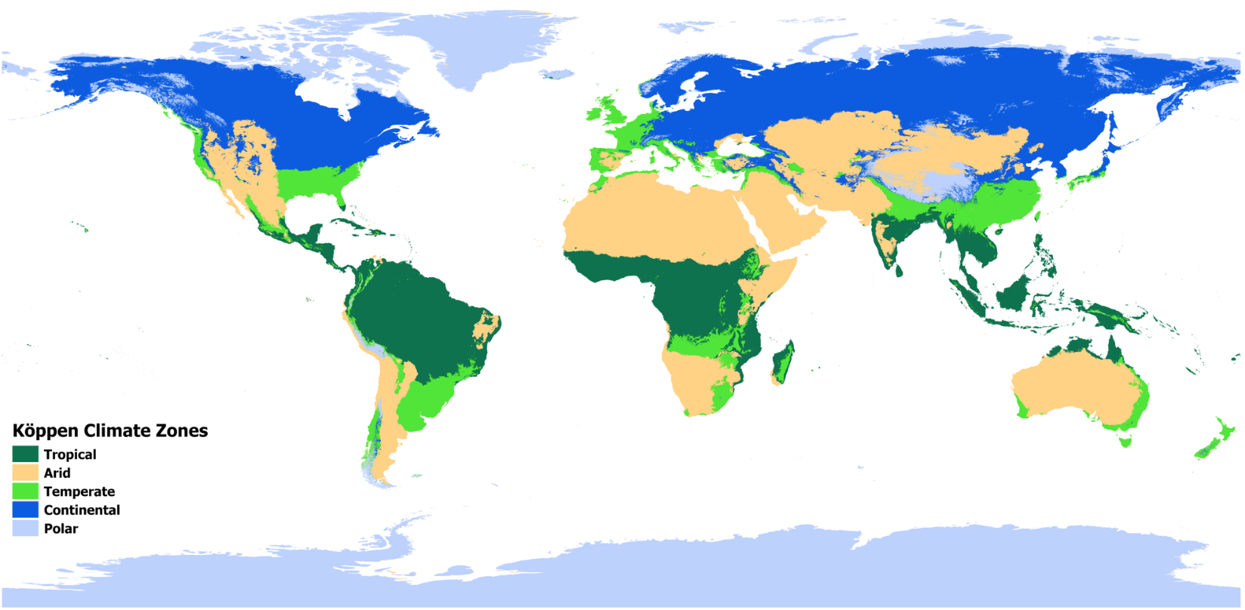

**Figure 1. Köppen Climate Regions.** Designated climate regions of the world using the Koppen Climate Zones system.

**Figure 2. Country Development Level.** Development level as denoted by the Human Development Index (HDI).

Figure 3. World Health Organization (WHO) regions.

Figure 4. Lancet countdown regions and urban greenness.



**Figure 5. Urban greenness in 1,041 urban centres in 2023.** Levels of urban greenness were quantified on the basis of mean population-weighted peak-season normalized difference vegetation index (NDVI). The NDVI is a standard, satellite-based measurement used to estimate vegetation on a scale of -1.0 to 1.0.

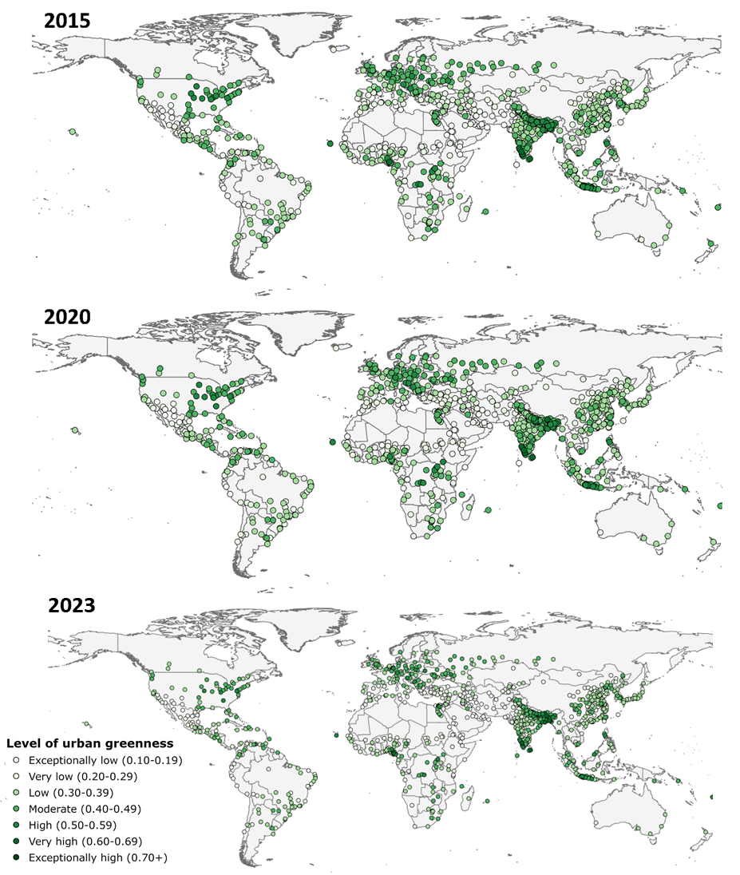

**Figure 6. Temporal changes in urban greenness.** Levels of urban greenness change between 2015, 2020, and 2023.

Figure 7. Percentage of urban centres by urban greenness level over multiple years.



Figure 8. Mean, population-weighted peak-season NDVI by climate region and year.

Figure 9. Mean, population-weighted peak-season NDVI by HDI and year.

Figure 10. Mean, population-weighted peak-season NDVI by WHO region and year.

Figure 7. Mean, population-weighted peak-season NDVI by Lancet Countdown Region designation and year.

#### References

(1) Florczyk A, Corbane C, Schiavina M, Pesaresi M, Maffenini L, Melchiorri M, et al. GHS Urban Centre Database 2015, multitemporal and multidimensional attributes, R2019A. European Commission, Joint Research Centre (JRC) [Dataset]. , 2022.

(2) Center for International Earth Science Information Network - CIESIN, - Columbia University. Gridded Population of the World, Version 4 (GPWv4): Population Density Adjusted to Match 2015 Revision UN WPP Country Totals, Revision 11. 2018; Available at: https://doi.org/10.7927/H4F47M65.

(3) Kriegler FJ, Malila WA, Nalepka RF, Richardson W. Preprocessing Transformations and Their Effects on Multispectral Recognition. Proceedings of the Sixth International Symposium on Remote Sensing of Environment 1969:97.

(4) Landsat Missions. Landsat Data Access. Available at: https://www.usgs.gov/landsat-missions/landsat-data-access.

(5) Beck HE, Zimmermann NE, McVicar TR, Vergopolan N, Berg A, Wood EF. Present and future Köppen-Geiger climate classification maps at 1-km resolution. Sci Data 2018 -10-30;5(1):1-12.

(6) Human Development Index (HDI). United Nations Development Programme.

(7) Rugel EJ, Henderson SB, Carpiano RM, Brauer M. Beyond the Normalized Difference Vegetation Index (NDVI): Developing a Natural Space Index for population-level health research. Environ Res 2017 NOV;159:474-483.

(8) Fong KC, Hart JE, James P. A Review of Epidemiologic Studies on Greenness and Health: Updated Literature Through 2017. Current Environmental Health Reports, 2018 MAR;5(1):77-87.

(9) Iungman T, Cirach M, Marando F, et al. Cooling cities through urban green infrastructure: a health impact assessment of European cities. The Lancet, Volume 401, Issue 10376, 577 - 589